# Part A – Columnar-Transposition-Cipher-Algorithm-MC68HC11F1-

## Pseudocode

**Main**

GenerateCodes()

InitilisePointers()

While true

GetKey inputted

Read switch and select encryption or decryption

Read 36 characters from users – Timeout 10seconds after input

Run Cipher

Run cipher again

Trim output

Display Output

Wait 5 seconds

**Cipher**

Fill Table

Apply cipher

Convert table to string

**FillTable**

Iterate over string

If encrypting put string into table column by column otherwise row by row

**ApplyCipher**

If encrypting sort rows into order of encryption key

Otherwise unscramble rows back into 123456

**TableToString**

If encrypting read table column by column otherwise read row by row

**Trim**

Remove trailing and leading spaces

Return length

## State Diagram

Main

Init

Set memory addr

Fill Keys array

GenCodes

Clear string memory – Fill with spaces

ClearString

GetKey

Get Key with user inputted key id

Turn integer into an int array

SplitNum

Get char from serial register

MGetChar

Get 36 char string

MGets

Filltable

Cipher

Start cipher sequence

X2

Trim leading and trailing spaces. Return length

Trim

Applycipher

Use hardware clock to wait after algorithm is completed

Sleep

TableToString

## Program Demo

### Encryption/Decryption

Encrypt ‘Hello my name is haydn’ with key ‘117’

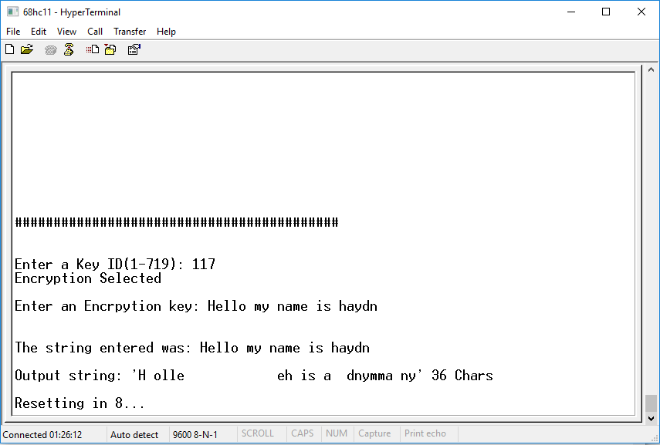

Decrypt ‘H olle eh is a dnymma ny’ with key ‘117’

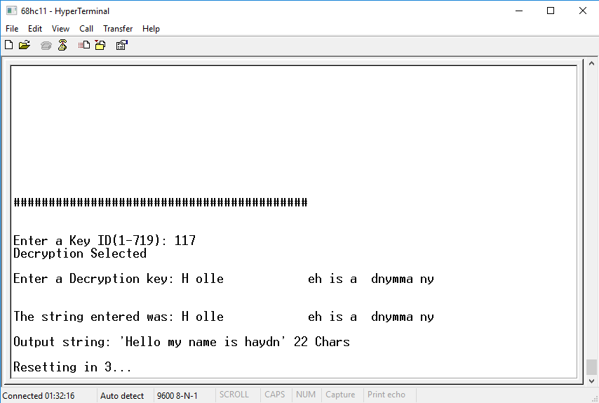

The program correctly encrypts and decrypts

### String input timeout

Wait 10 seconds after typing

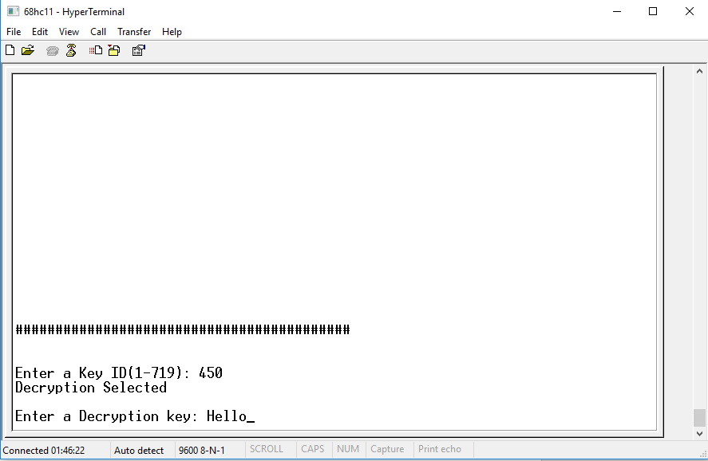

10 seconds pass, it timeouts and restarts after 3 seconds

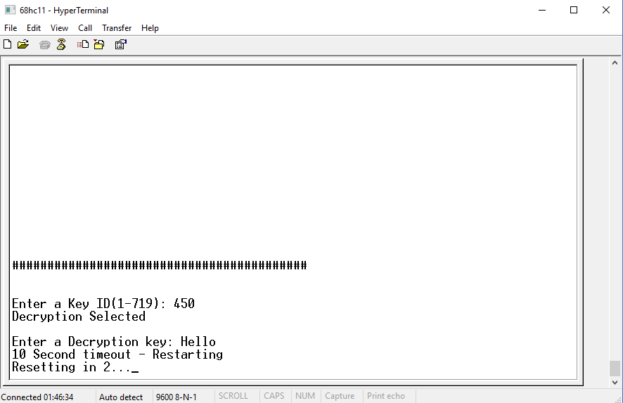

## Testing

|  |  |  |  |  |
| --- | --- | --- | --- | --- |
| Test | Input | Result | Image | Fix |
| Captures 36 chars | ‘Hello my name is haydn this string is too long’ 46 chars | ‘Hello my name is haydn this string is ’ 37 chars  It captured 1 too many, this is a simple fix. |  |  |
|  |  |  |  |  |
| Key ID Range | -10 | Correctly ask for key again |  |  |
|  | 0 | Correctly ask for key again |  |  |
|  | 1 | Correctly accepts key id |  |  |
|  | 719 | Correctly accepts key id |  |  |
|  | 720 | Correctly ask for key again |  |  |
|  | 800 | Correctly ask for key again |  |  |
|  |  |  |  |  |
| Encryption | Key = 718  654312  Text = The answer is forty-two  Calculated by hand =  Expected = ‘ owty-trofs na eThi resw’ | Correctly encrypts |  |  |
| Decryption | Key = 718  654312  Text = ‘ owty-trofs na eThi resw’  Expected = ‘The answer is forty-two’ | Correctly decrypts |  |  |
| Encryption and decryption | Key = 465  Input = Hello my name is haydn  I should recived the same text back after decrypting | Correctly encrypts and decrypts |  |  |